|  |
| --- |
| Lazy Cat Games |
| Run!! |
| **Run Game** |
| Version #1.0.0  All work Copyright © 2016 by Lazy Cat Games.  All rights reserved. |
| **Waynell** |
|  |

|  |
| --- |
| November 6th 2016 |

**Table of Contents**

[Your Table of Contents should go here. Make sure that your document’s sections are hyperlinked to their corresponding pages.]

**Version History**

https://github.com/WaynellLovell/Assignment3-Run-

1. **Game Overview**

**Goal is to finish the maze before you flash light runs out**

1. **Camera**

*(Point of View)*

1. **Controls**

*Wasd keys, space to jump and shift to run*

1. **Saving and Loading**

*Game has Pause feature no saving;*

1. **Interface Sketch**

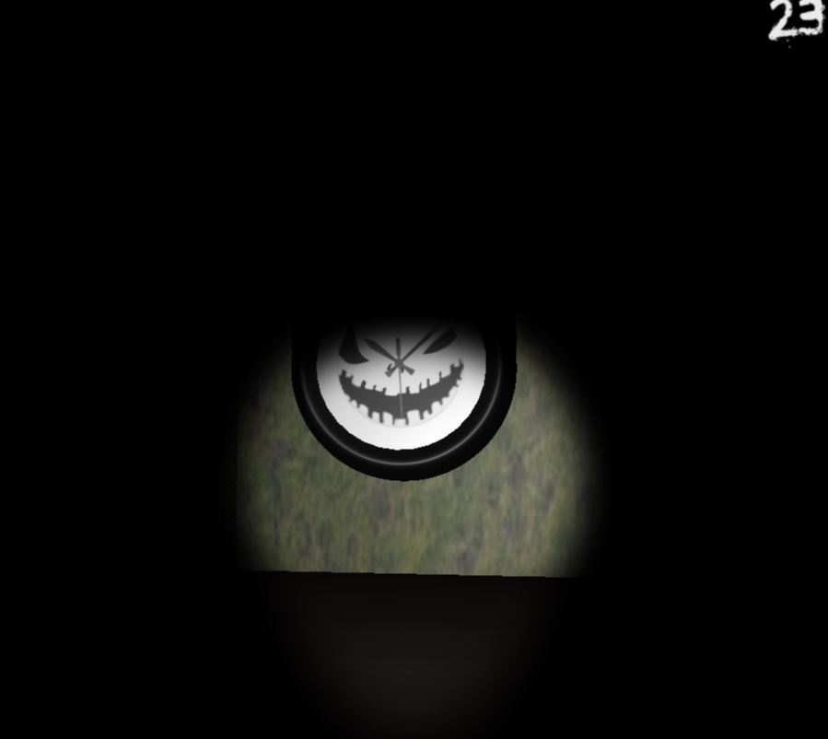

1. **Menu and Screen Descriptions**

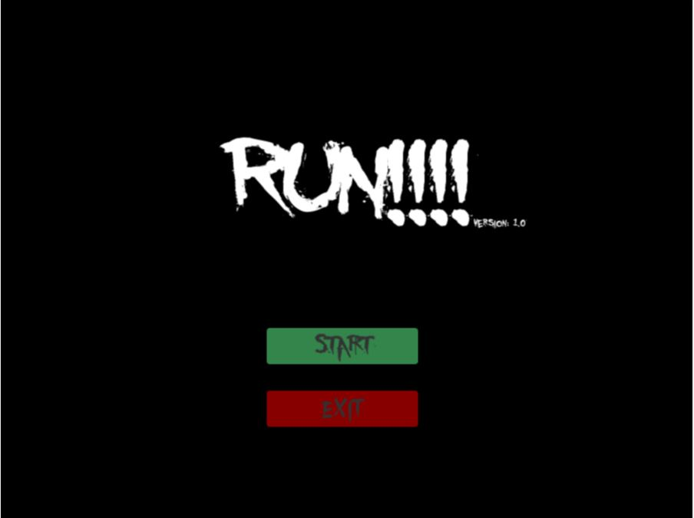

1. **Game World**

*The game world is a maze.*

1. **Characters**

*Player*

1. **Non-player Characters**

They are ghost they bom up and down, send player back to start or turning off their flash light.

1. **Enemies**

*Ghost*

1. **Items**

*Batteries for flash flight.*

1. **Script**

BatteryController

Clock_Controller

GameController

MainMenuScript

Player_Won_Controller

And Some Edits to the FirstPersonController

1. **Scoring**

Time it takes to finish the maze.

1. **Sound Index**

*Evil_laugh*

*FlashLightGoesOut*

*GamePlaySound*

*MainMenuSound*